Battle of Neighborhoods – Bangalore

Introduction:
I used to travel a lot to many new places as a trip. It’s cumbersome task to choose an hotel at a optimal location which is nearby to all/maximum tourist places. By this, it would be easy for any traveller to book an hotel and cover maximum tourist spots.

Solution:
I would be building an app, which takes the location from the traveller where he is going to travel. Obtain all tourists places, hotels, restaurants etc. available around that town using Foursquare API. Find an optimal area and give an list of hotels and its ratings & reviews for the user to select.

Data:
I would be using Foursquare API data to extract venues, places, ratings etc. and geopy to obtain location data. I would perform clustering based on different areas to obtain local and global optima. I would use folium library to visualise areas in maps. For an Example I’ll be using Bangalore/India location dataset from kaggle.com.
key | area_name | state | latitude | longitude | accuracy
0 | IN/560001 | Rajbhavan | Karnataka | 12.2667 | 76.6833 | NaN
1 | IN/560002 | Chamarajendrapeta | Karnataka | 12.2667 | 76.6833 | NaN
2 | IN/560003 | Extension | Karnataka | 12.2667 | 76.6833 | 4.0
3 | IN/560004 | Lalbagh West | Karnataka | 12.2667 | 76.6833 | NaN
4 | IN/560005 | Fraser Town | Karnataka | 12.2667 | 76.6833 | NaN

Obtain Latitude and longitude values of Central Bangalore
Location data can be retrieved for any given location using geopy packages as we have seen in previous courses. I have retrieved location data of central bangalore which will be helpful in plotting on folium map

Tourist places in Bangalore
The below data is obtained with the help of foursquare API. Data is then processsed to get in reasonable format with all required informations in place.
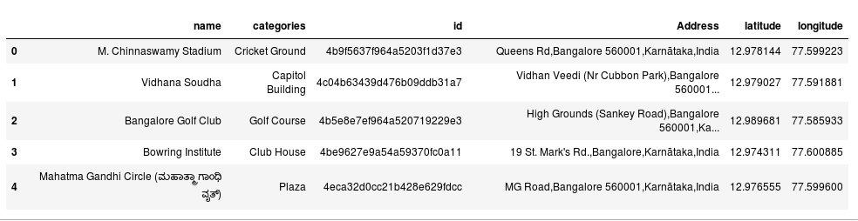

Methodology
Now we find the centroid of all tourist places using any ML model like in this case (K means clustering). Centroid can be obtained easily by distance measurements of places and finding an intersection where all lines meetup. In this project I have taken Lalbagh West as an centroid area. So we will search for hotels in this area using FourSquare API. we will find ratings, reviews, pricing and get a list of top 5 best hotels to choose in lalbagh west.
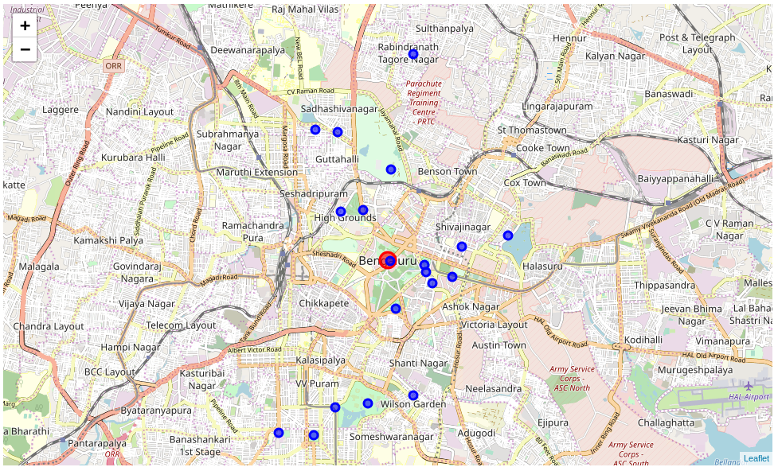

Location data of Lalabagh West
12.94646125 77.5800458707851

Final Output
This would be the output given to the user, which contains top 5 hotels with its ratings and reviews in place.
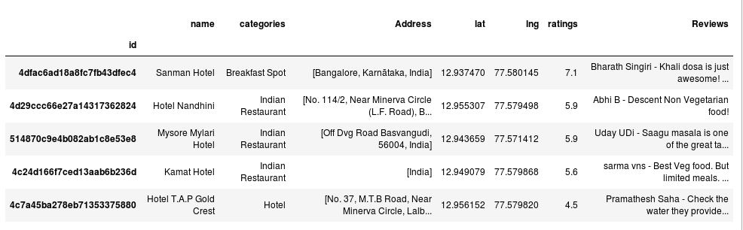

Results
This applicaion will now be able to suggest an traveller visiting bangalore to choose an best area to stay and best hotel to book.
The final output displays top 5 hotels of best suitable area with ratings and reviews.

Discussion:
After an data analysis I have found that there many venues which has no detailed address mentioned. I have extracted address using location data available from geopy package.

Conclusion:
So now any user using this application will now be able to will be able to
- Enter any desired location he is planning to visit
- Get the list of tourist places in that location
- The Model will find an optimal area which is nearby to many tourist places
- Provide a list of top 5 hotels in an optimal area with ratings and reviews

